Metal Box

Polymer Box

Panel Protector / Hardwire / M200/120/208 3Y 2nd Edition

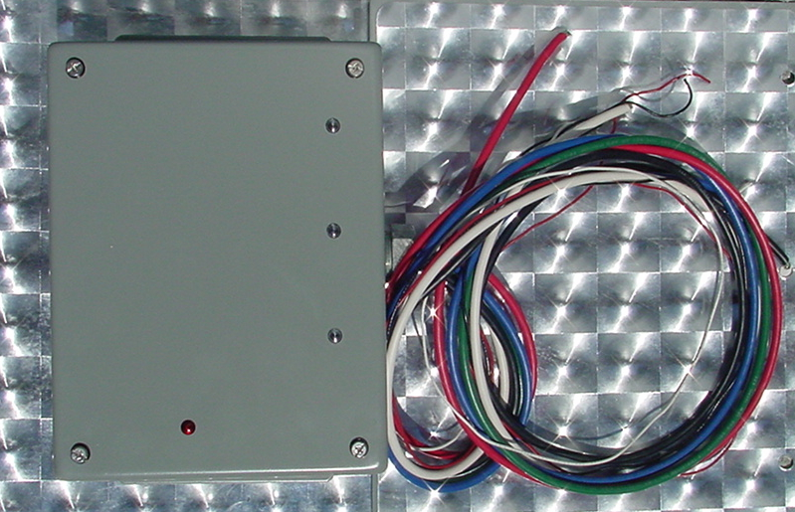
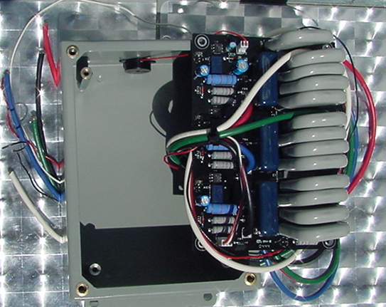

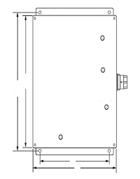

Specifications - Operating: Dry Contacts
8 3/4
8
Maximum Operating Voltage: 208 Volts AC
Typical Leakage Current: <5µ amps
Operation Temperature: - 40 to +85°C
Connectors: Hardwired
Lines Protected: L-L, L-G, N-G
Installation Configuration: Parallel
4

Specifications - Electronic:
6 1/4
Maximum Surge Current (8x20µs): 600,000A total, 200KA per Phase
Maximum Surge Voltage (1.2x50µs): 10,000 Volts
Capacitance: <2,000 pf
Clamping Voltage: 250 Volts RMS
Clamping Response Time: <5 nanoseconds
Current: Non-Load Bearing
Voltage: Voltage Sensitive
Design: (3) Thermally Fused Hybrid
Operation Indicators & Audible Alarm (4) Light Emitting Diode (LED)
Power Dissipation (8x20µs): 102,000,000 Volts Amps
Energy Dissipation: 7600 Joules
UL 1449: 1449 Second Edition
UL and CUL Approved: United States / Canada
Dimension: Depth 3 1/2"
Length 8 3/4"(including tabs)
Width 6 1/4"
Weight: Approximately 7.5 lbs Nema 12 Box

Pass Voltage Tested to ANSI/IEEE B3 Impulse: (L-L)800VoltsPeak(L-G)400V PK (L-N)400V Pk(N-G)400V Pk
Stormin surge suppressors have a Ten Year Product Warranty. Please see warranty statement for complete product warranty information.
Page11
Click here for Index Click here for Page10 Click here for Page 12
Panel Protector / Hardwire / PTS 208 3Y H / 2nd Edition
Metal Box

Polymer Box
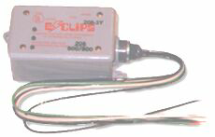

Specifications - Operating:
Maximum Operating Voltage: 208 Volts AC
Typical Leakage Current: <5µ amps
Operation Temperature: - 40 to +85°C
Connectors: Hardwired
Lines Protected: L-L, L-N, N-G, L-G

Installation Configuration: Parallel

Specifications - Electronic:
Maximum Surge Current (8x20µs): 300,000 Amps Total
Maximum Surge Voltage (1.2x50µs): 10,000 Volts
Capacitance: <2,000 pf
Clamping Voltage: 250 Volts RMS
Clamping Response Time: <5 nanoseconds
Current: Non-Load Bearing
Voltage: Voltage Sensitive
Design: Thermally Fused Hybrid
Operation Indicators: Light Emitting Diode (LED)
Power Dissipation (8x20µs): 39,000,000 Volts Amps
Energy Dissipation: 2850 Joules
UL 1449: 1449 Second Edition
UL Recognized Component: File E121637
UL and CUL Approved: United States / Canada
Dimension: Depth 2.500"
Width 4.750"
Length 5.800" (including tabs)
Weight: Approximately 2 lbs.

Pass Voltage Tested to ANSI/IEEE B3 Impulse: UL’s Best 330 V Peak Rating

E-Clips surge suppressors have a Ten Year Product Warranty. Please see warranty statement for complete product warranty information.
Click for Index Click Here for Page 10 Click here for Page 12

